**Regionals** starts with the default North America Region View

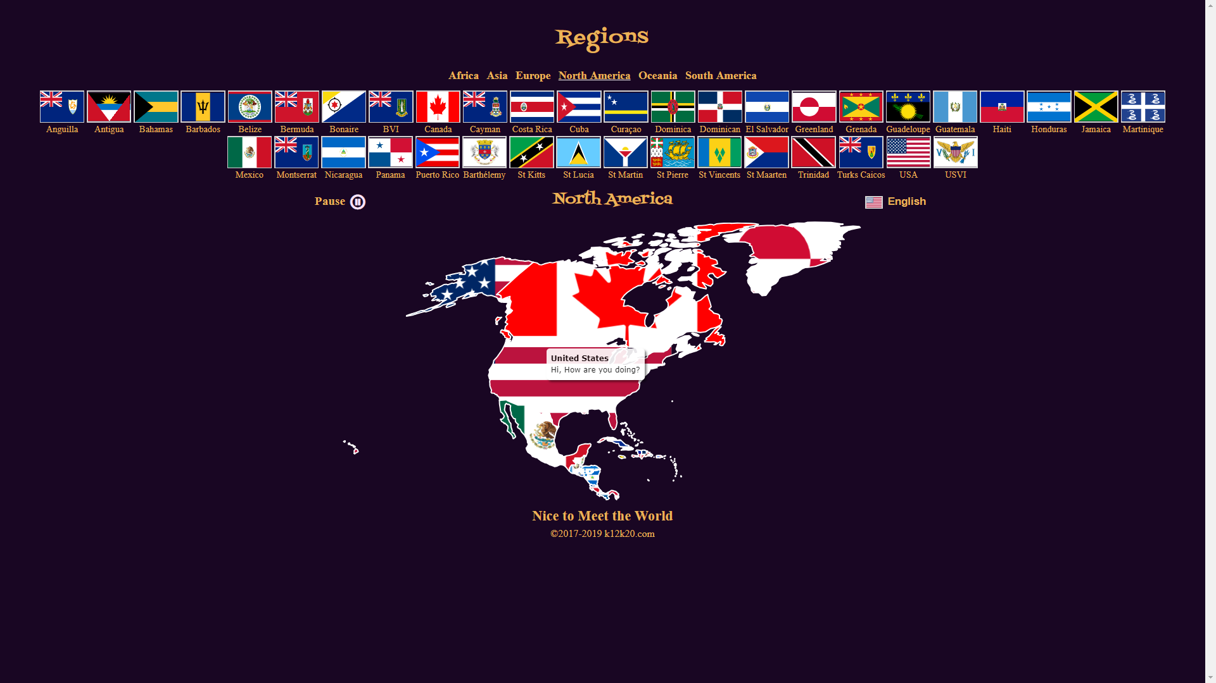

Clicking on the USA flag or on the map’s USA Flag while seeing the North America region will display the USA states view

After a country selected from a region, clicking the region button again will re-display the Region’s Map. After a state selected from the USA Map, clicking on the USA Flag will re-display the USA Map

USA States View

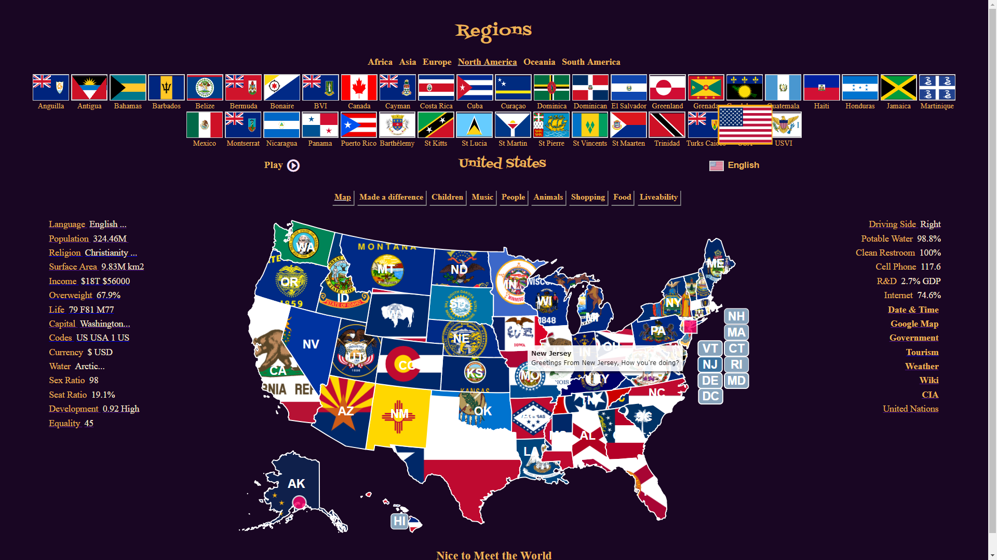

The USA State Maps and Flags are displayed together with the USA data and links on the sides

The Greeting and the Anthem will be heard. The “Pause or Play Icon” can be used to stop or start the greeting and/or anthem

On this level (Country) all the data and links belong to the USA

Clicking on “Tourism” link will display “Travel and Tourism Information, by State” page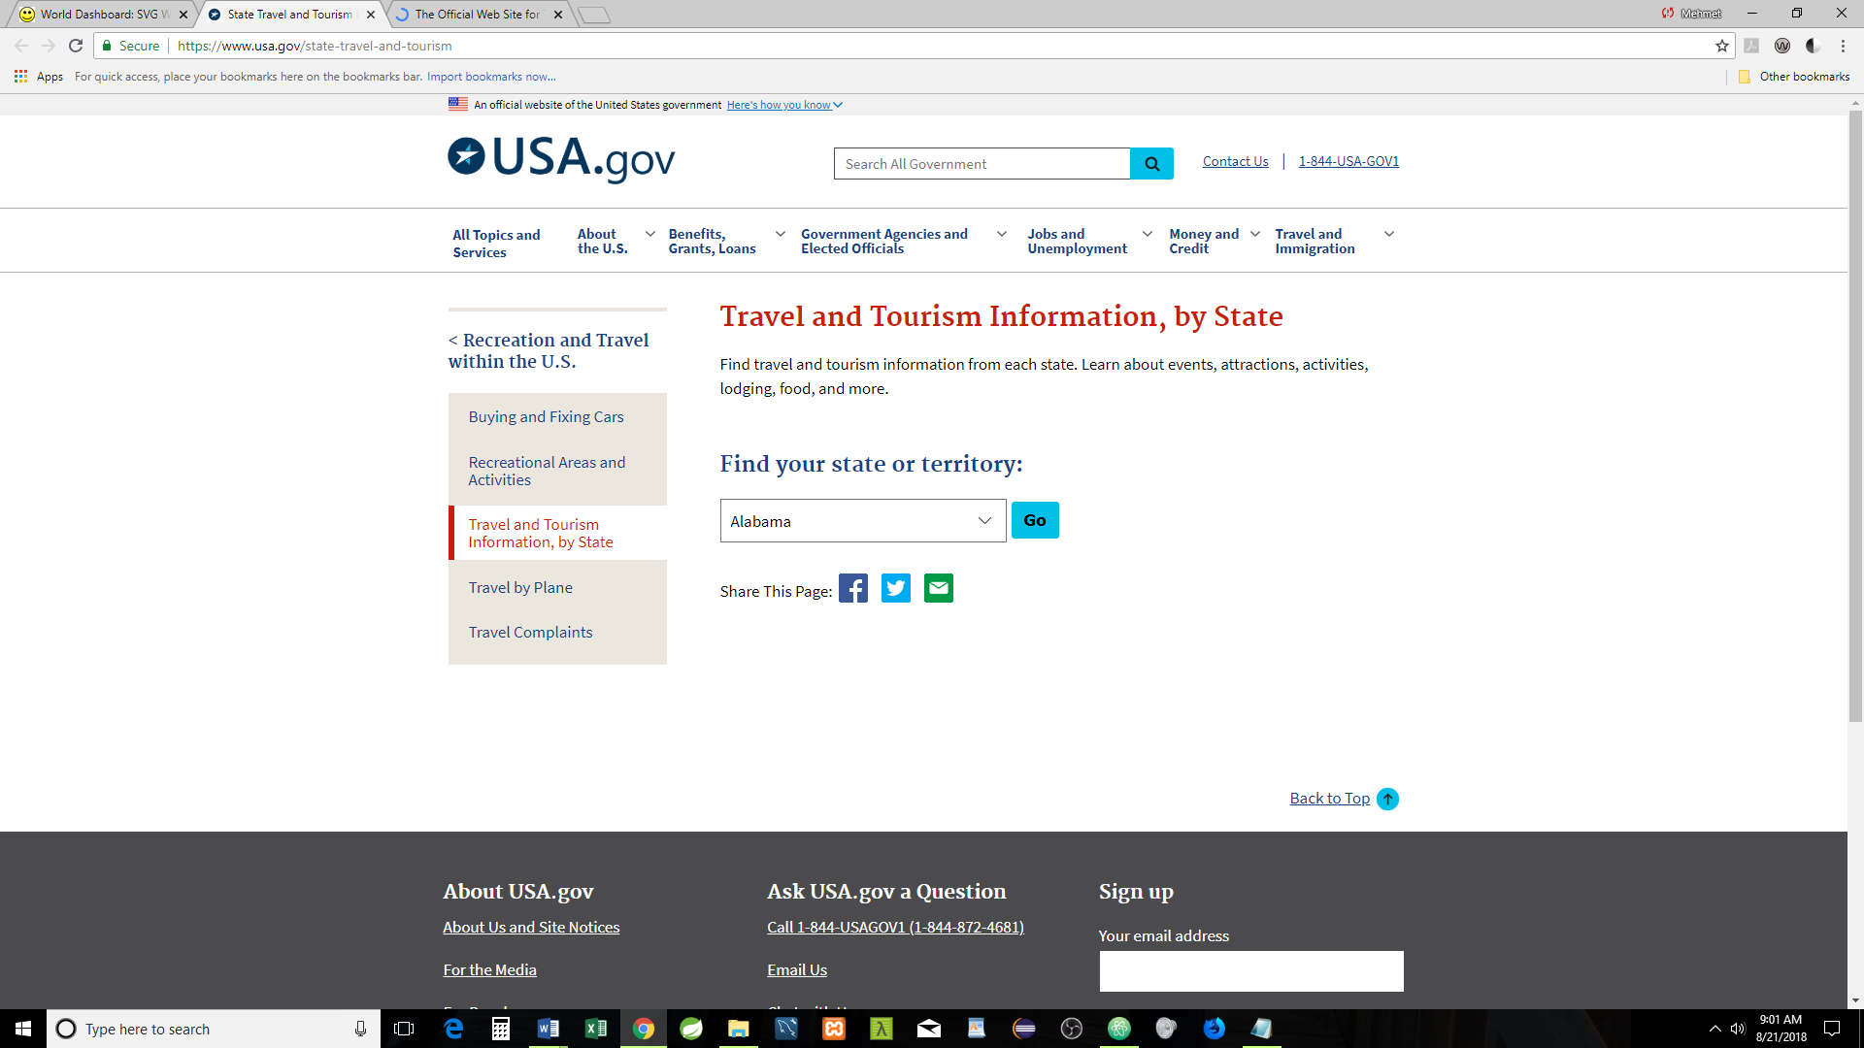

Click on the “Government” link will display the following picture



Clicking on the “Wiki” link will display “United States” page

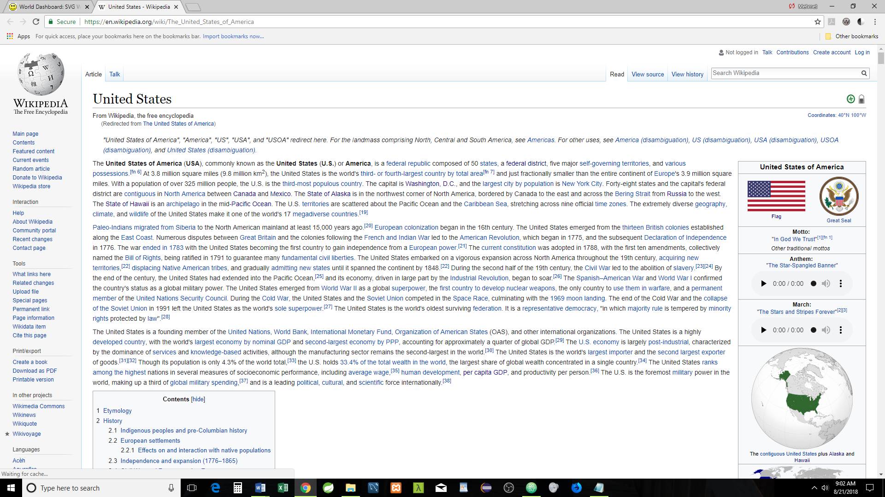

Clicking on the “CIA” will display CIA the WORLD FACTBOOK

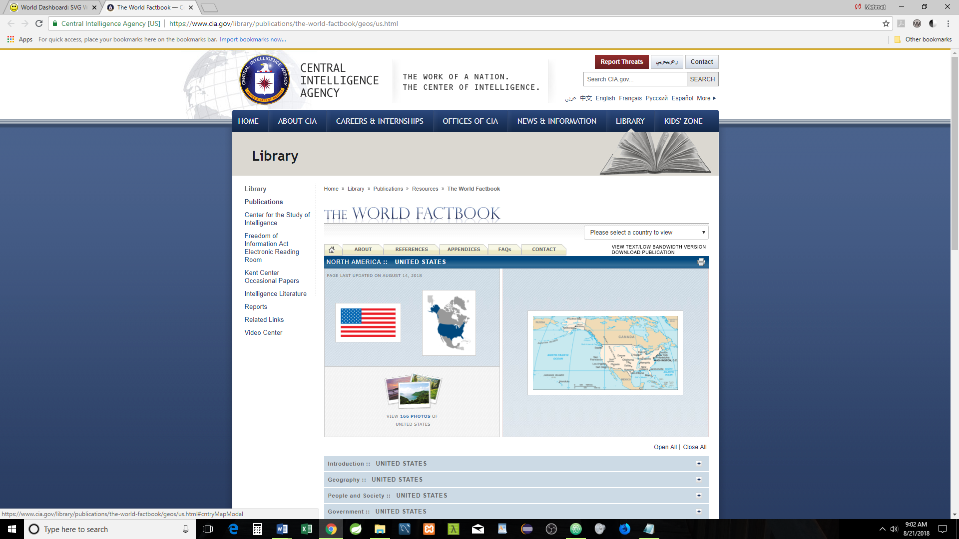

Clicking on “UN” will display UN’s United States of America information

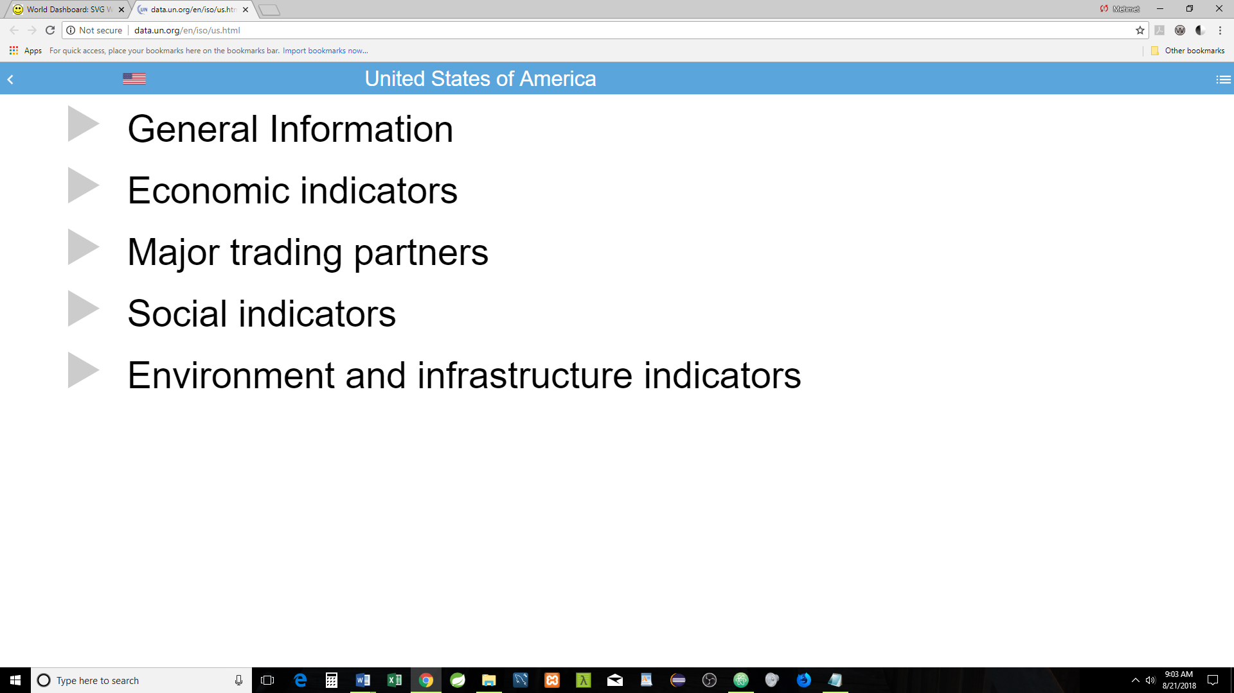

Clicking on the “Weather” link will display the US Capital weather (If API purchased, this can be internally displayed)

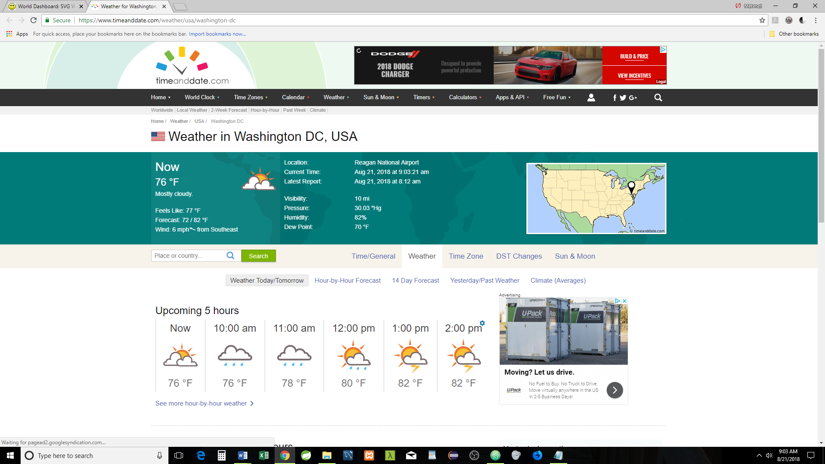

Clicking on the “Date & Time” link will display the US Capital Date & Time (If API purchased, this can be internally displayed)

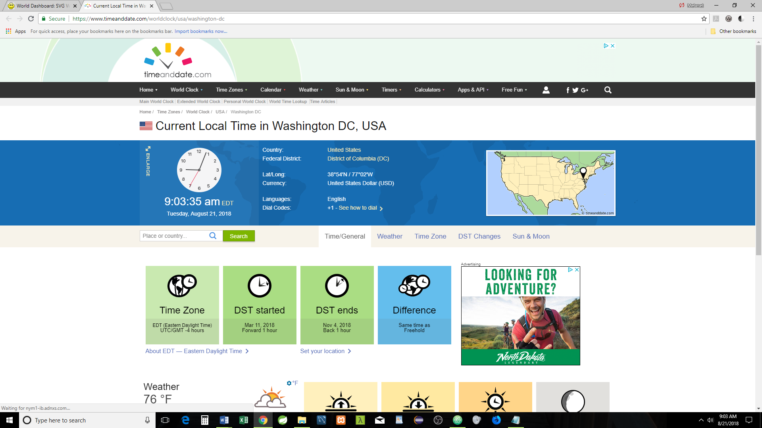

Clicking on Google Map will display United States map (If API purchased, this can be also be displayed internally)

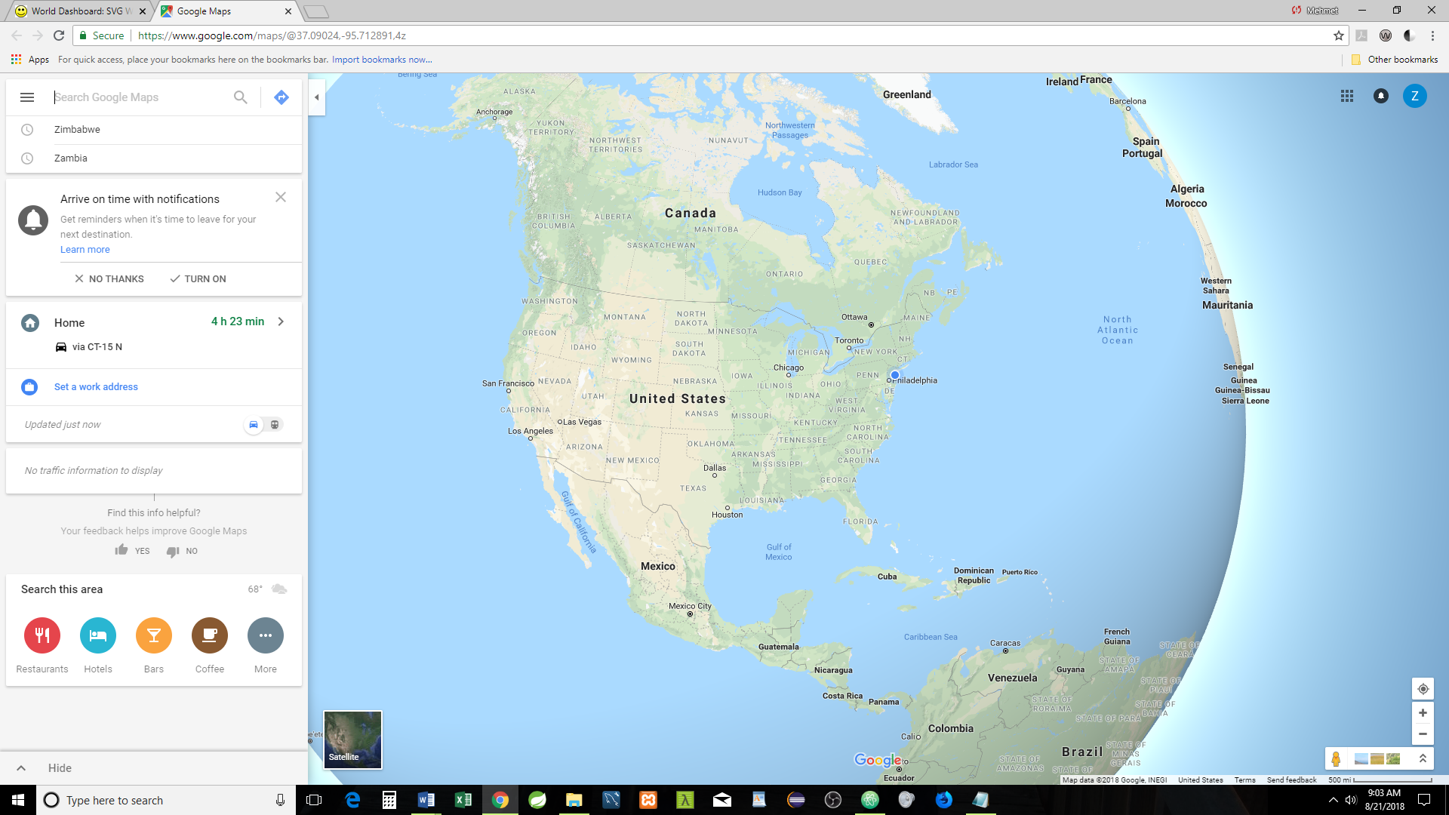

Clicking on the Capital (Washington D.C. in this case) will display Wiki’s Capital Page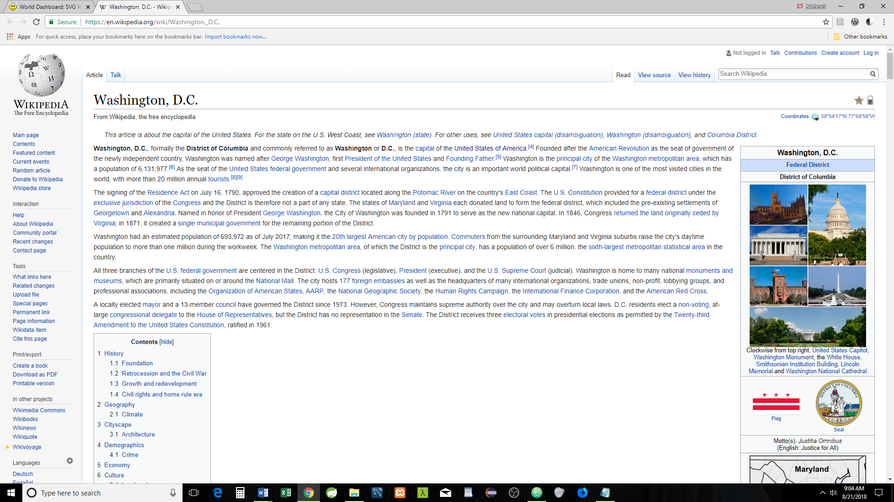

**State Level:** Clicking on any one of the 50 states or Washington D.C. will display the related Map: Florida is clicked

On this level (State) all the data and links belong to a State if applicable

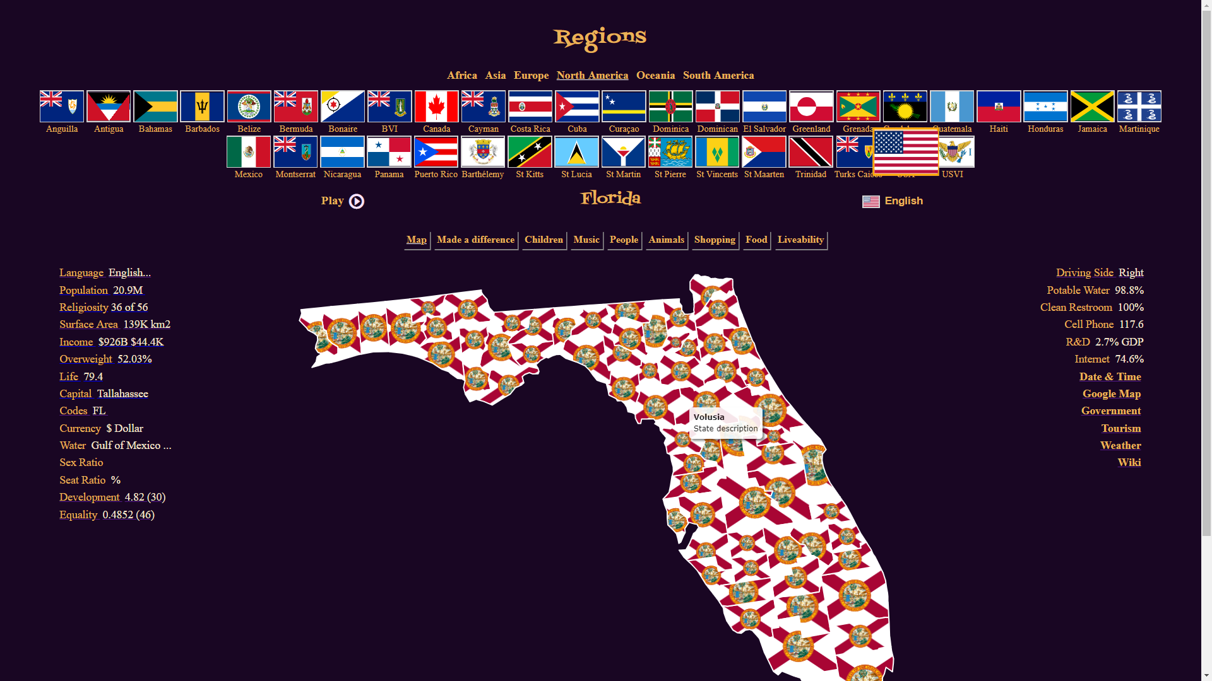

Clicking on “Tourism” link

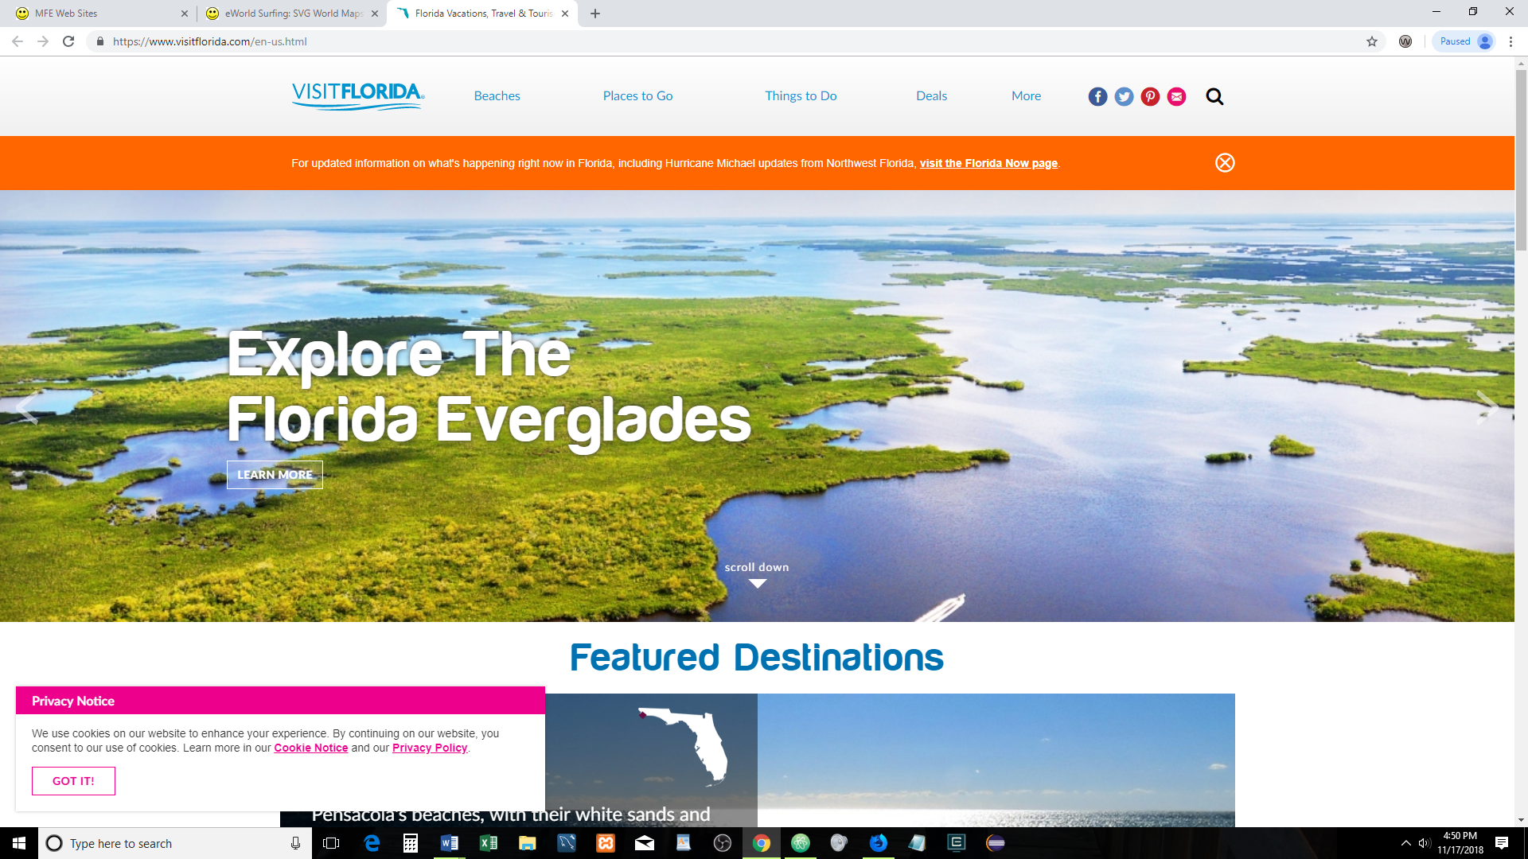

Clicking on “Government” link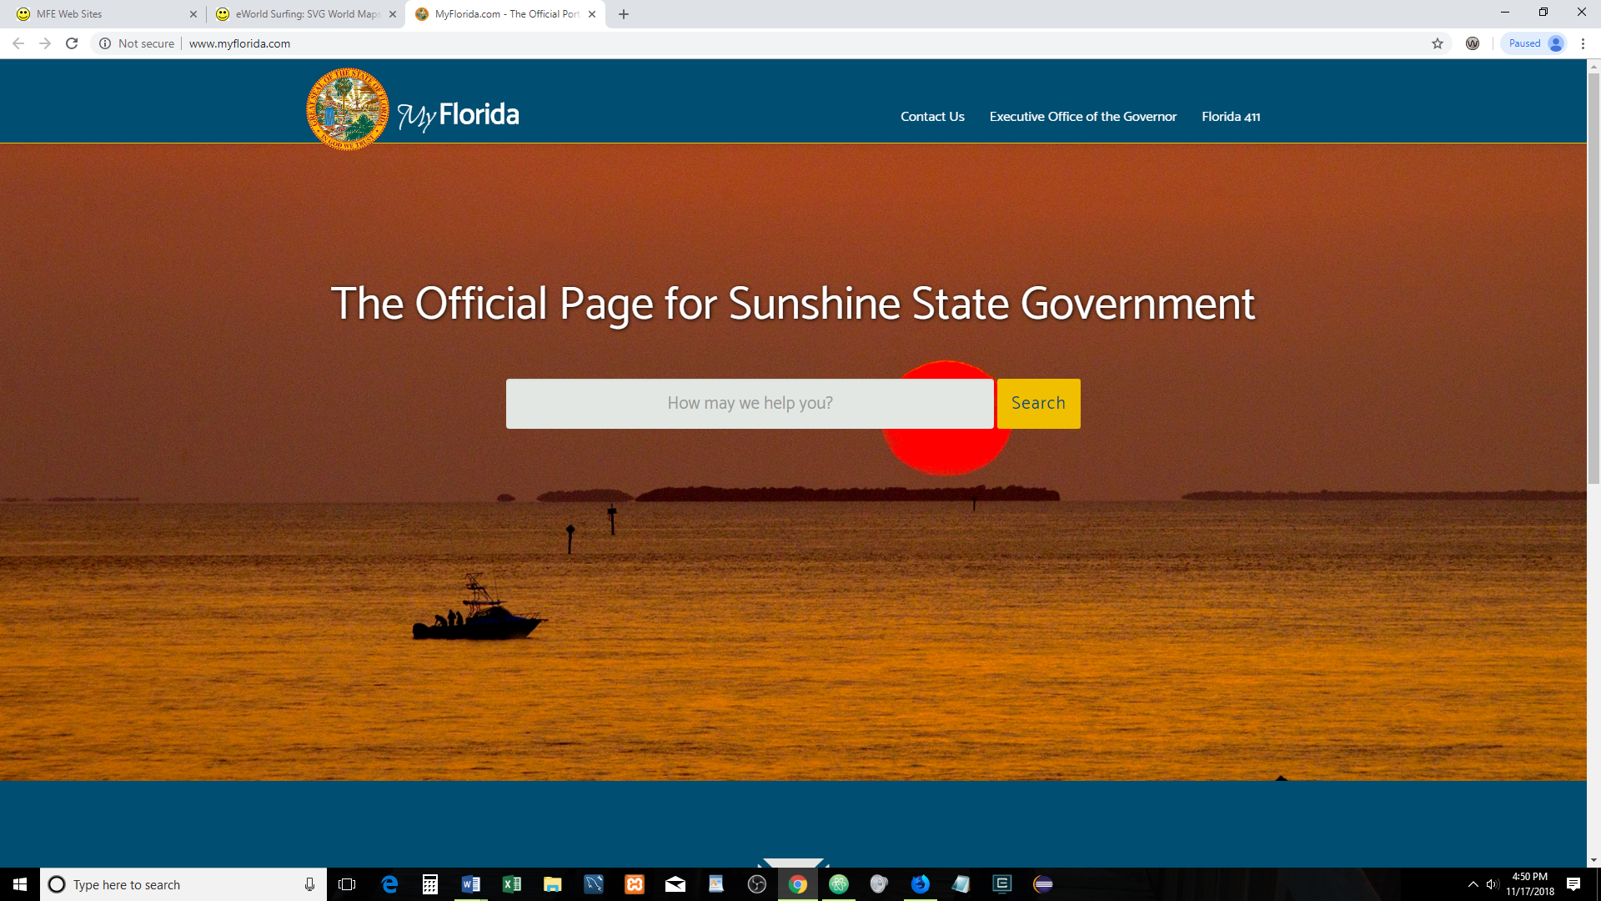

Clicking on “Wiki” link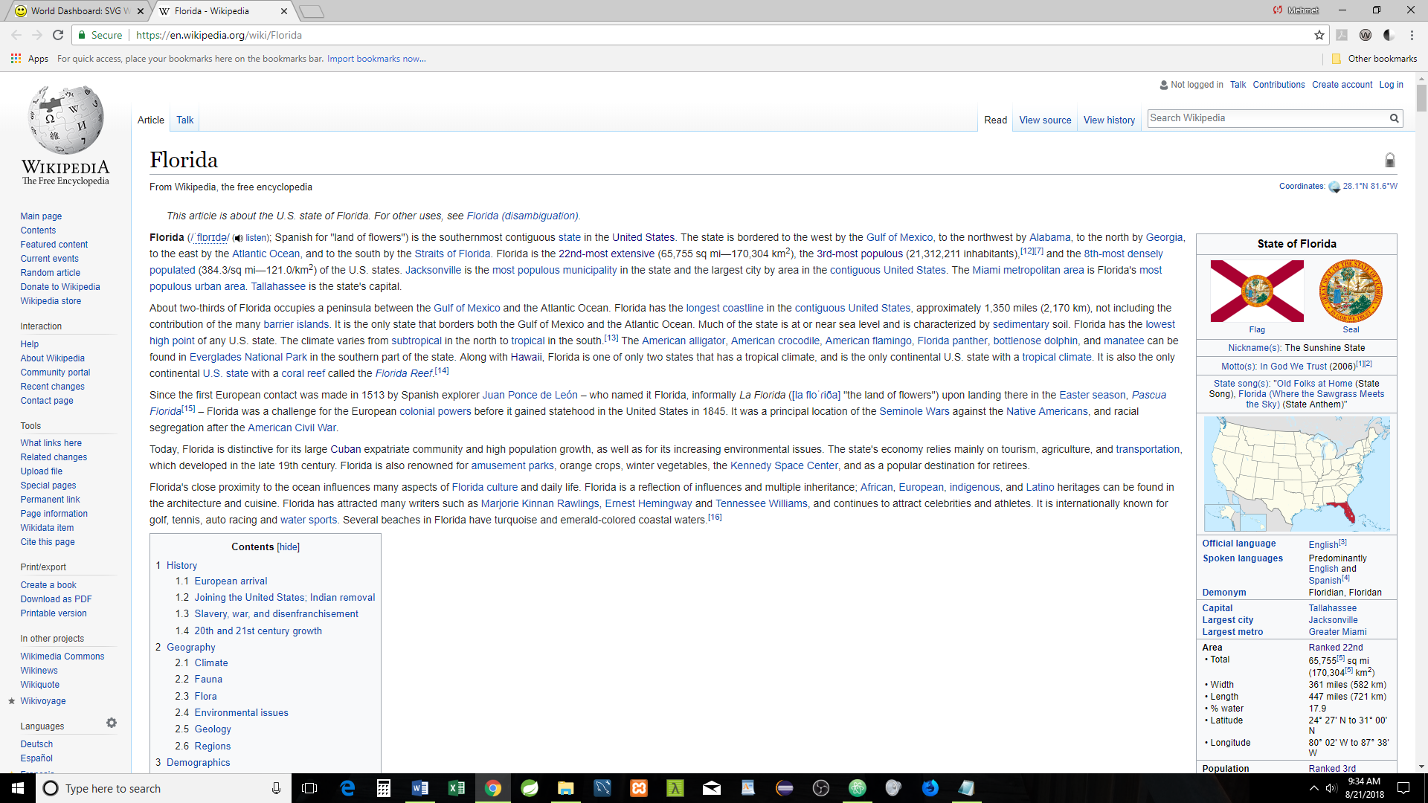

Clicking on “Weather” link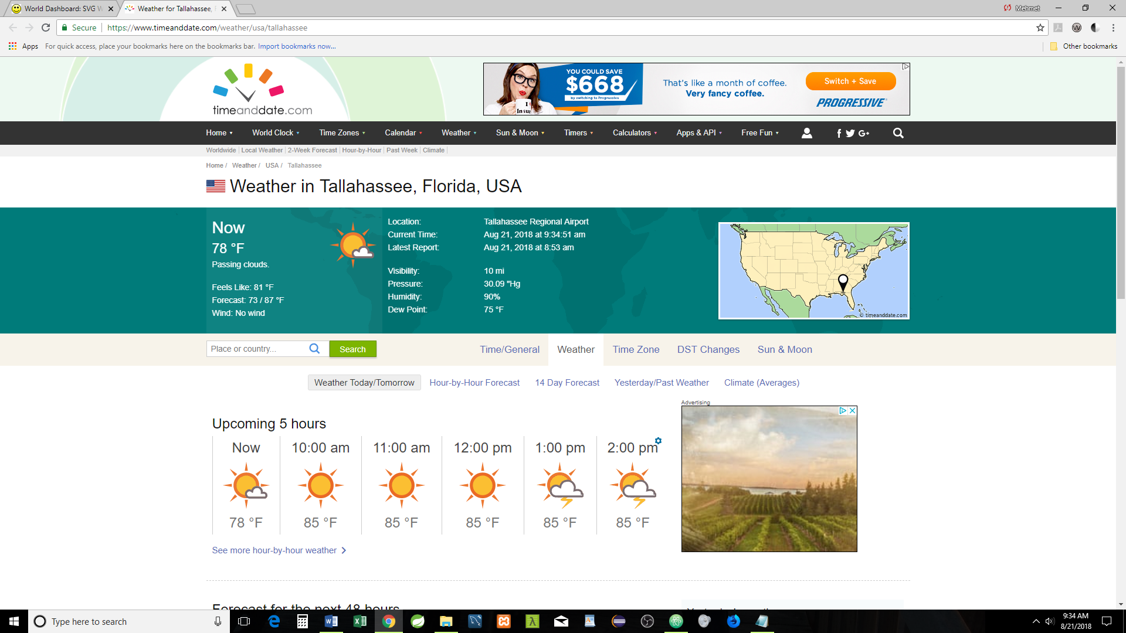

Clicking on “Date & Time” link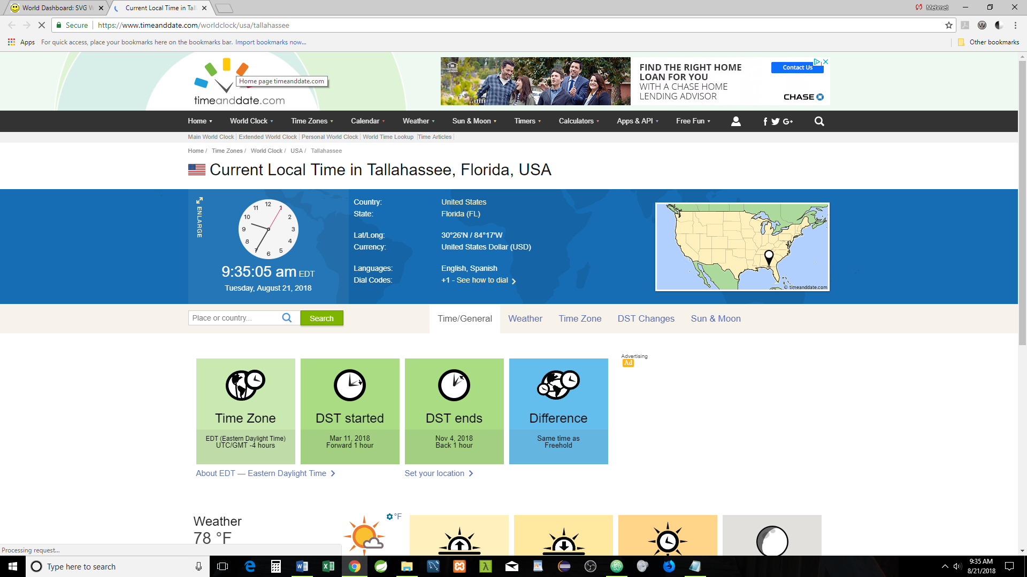

Clicking on “Google Map” link

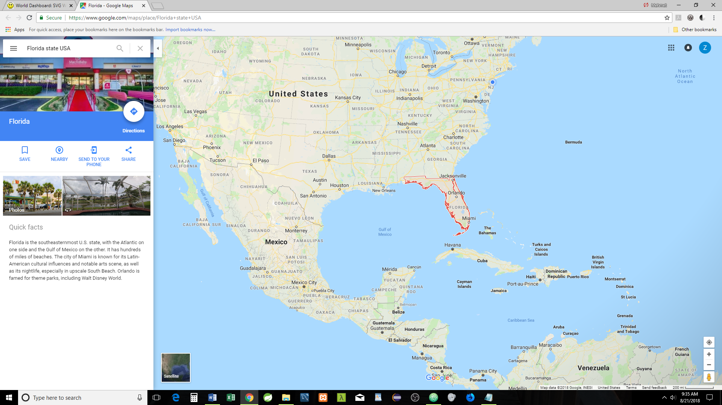

Clicking on “Capital” link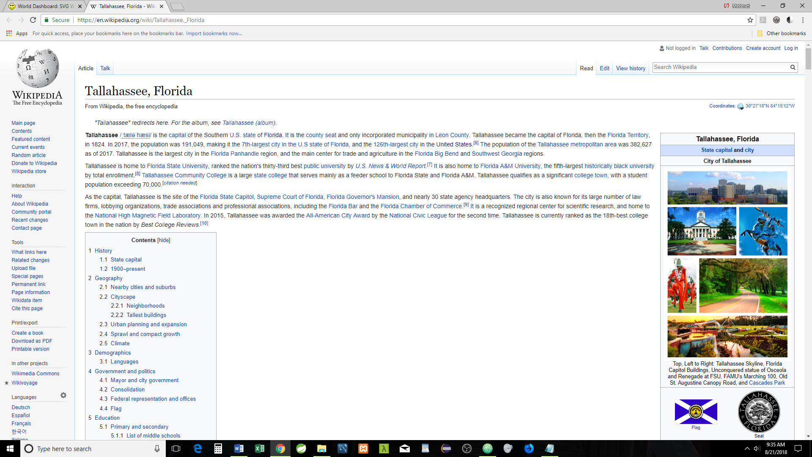

US State Abbreviations and Postal Codes

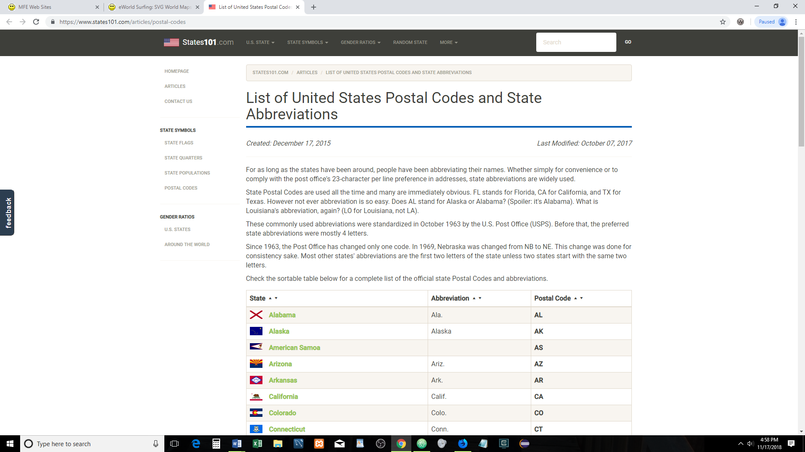

The following websites will be opened if the links on the Data (information) are clicked for any county

The World Languages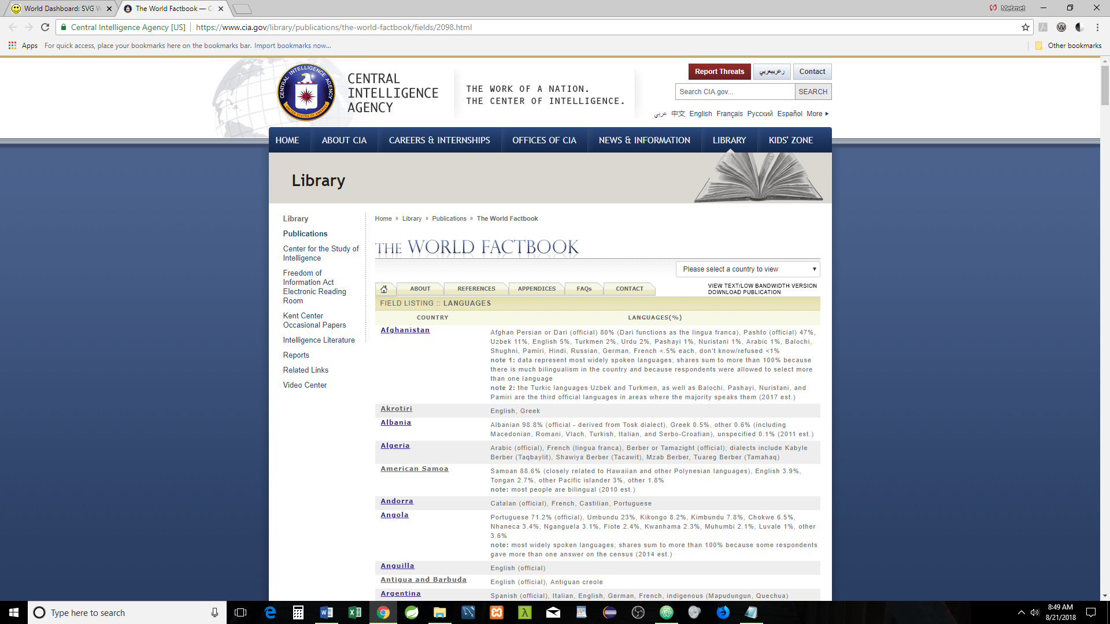

World Countries by Population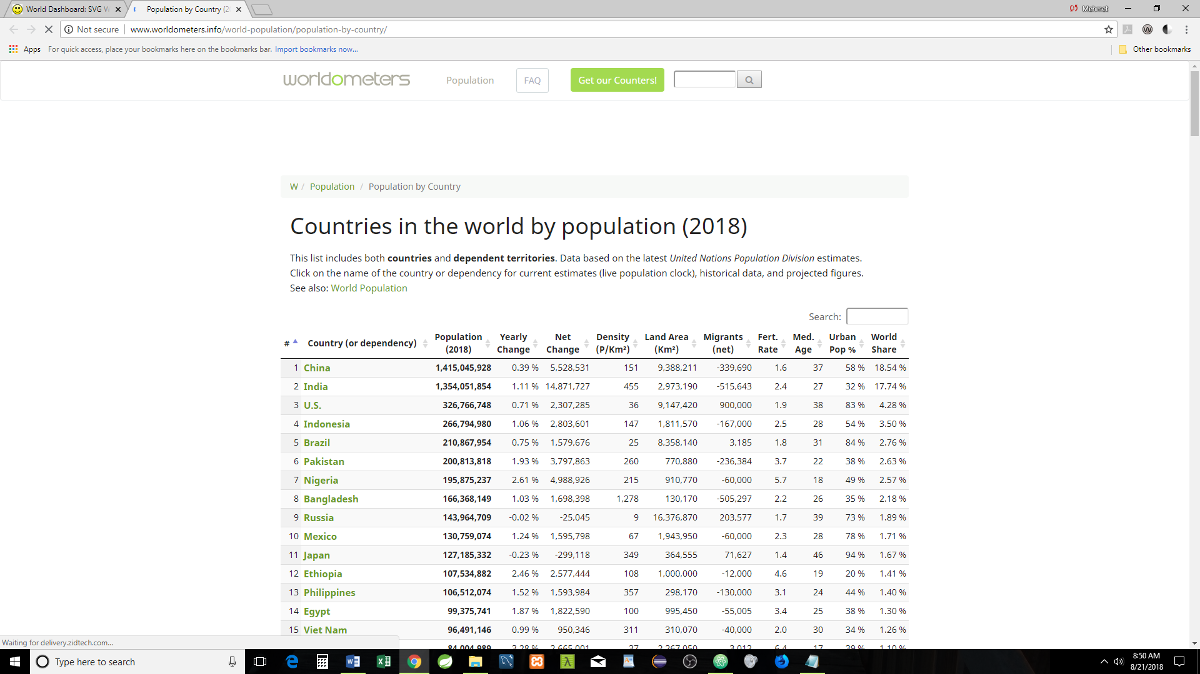

World Religions

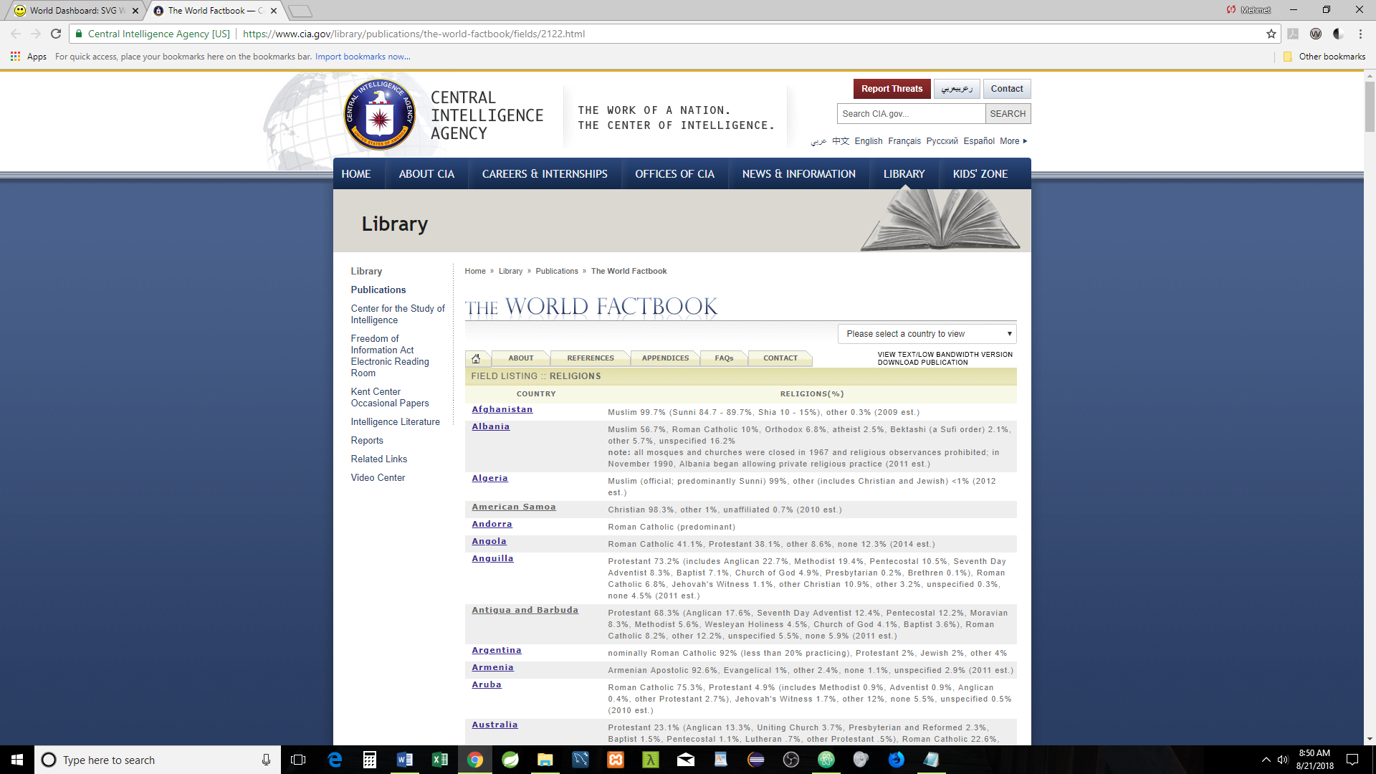

World Countries by Surface Area

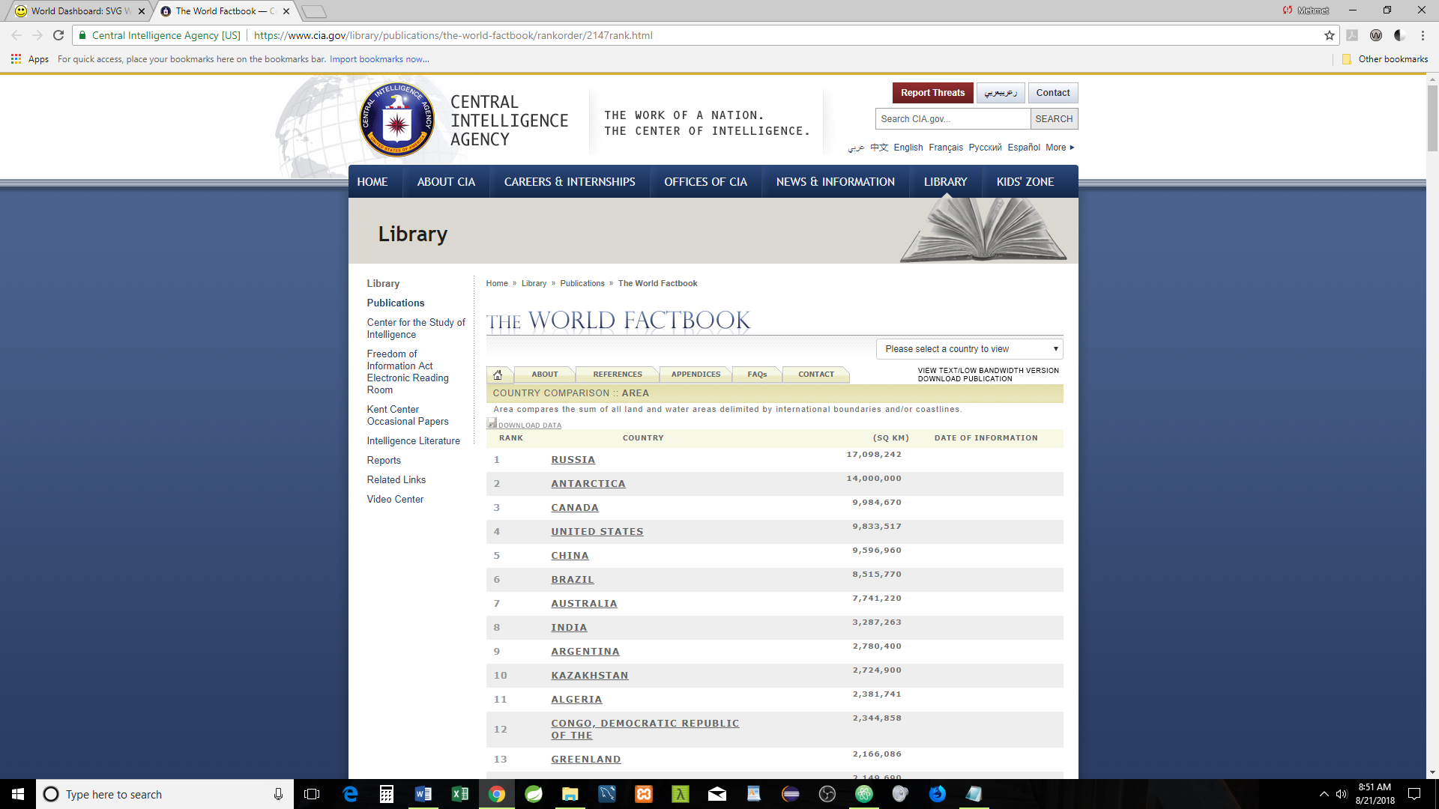

World Countries by GDP

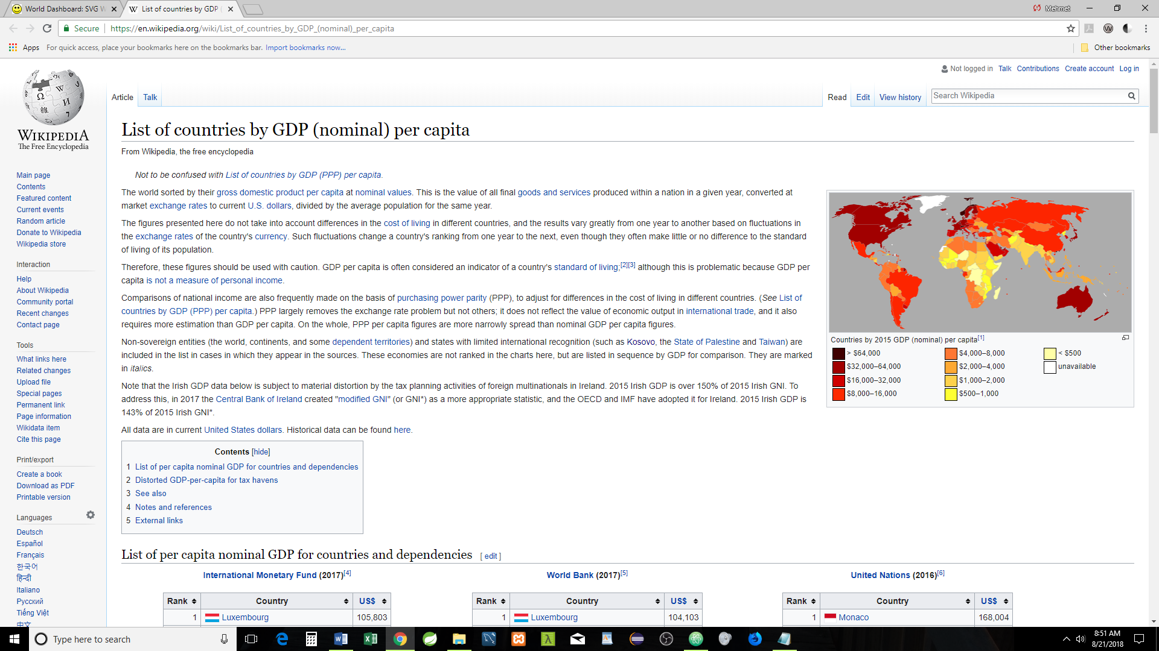

World Countries & Overweight and Obesity

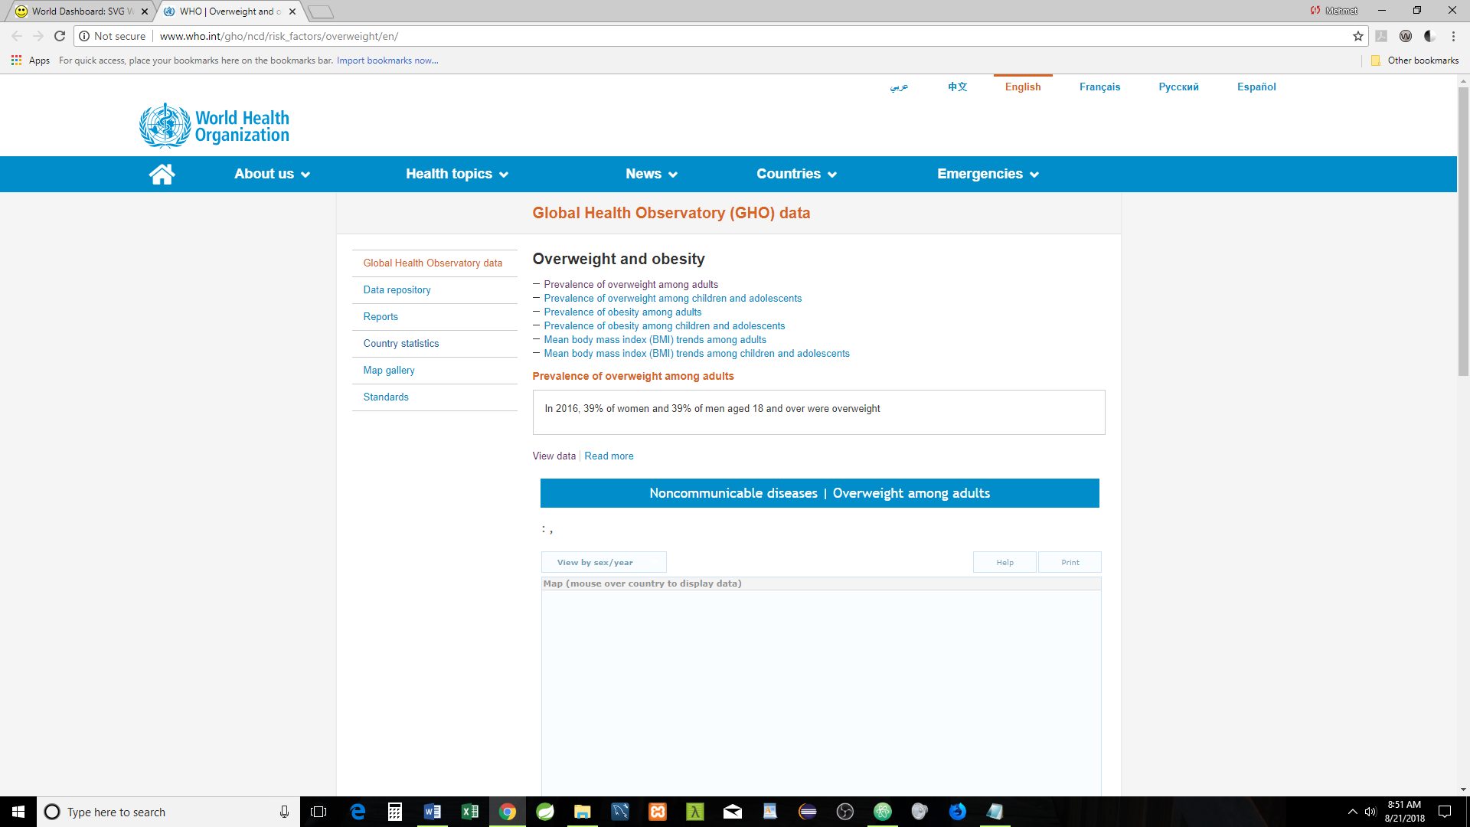

World Countries Life Expectancy

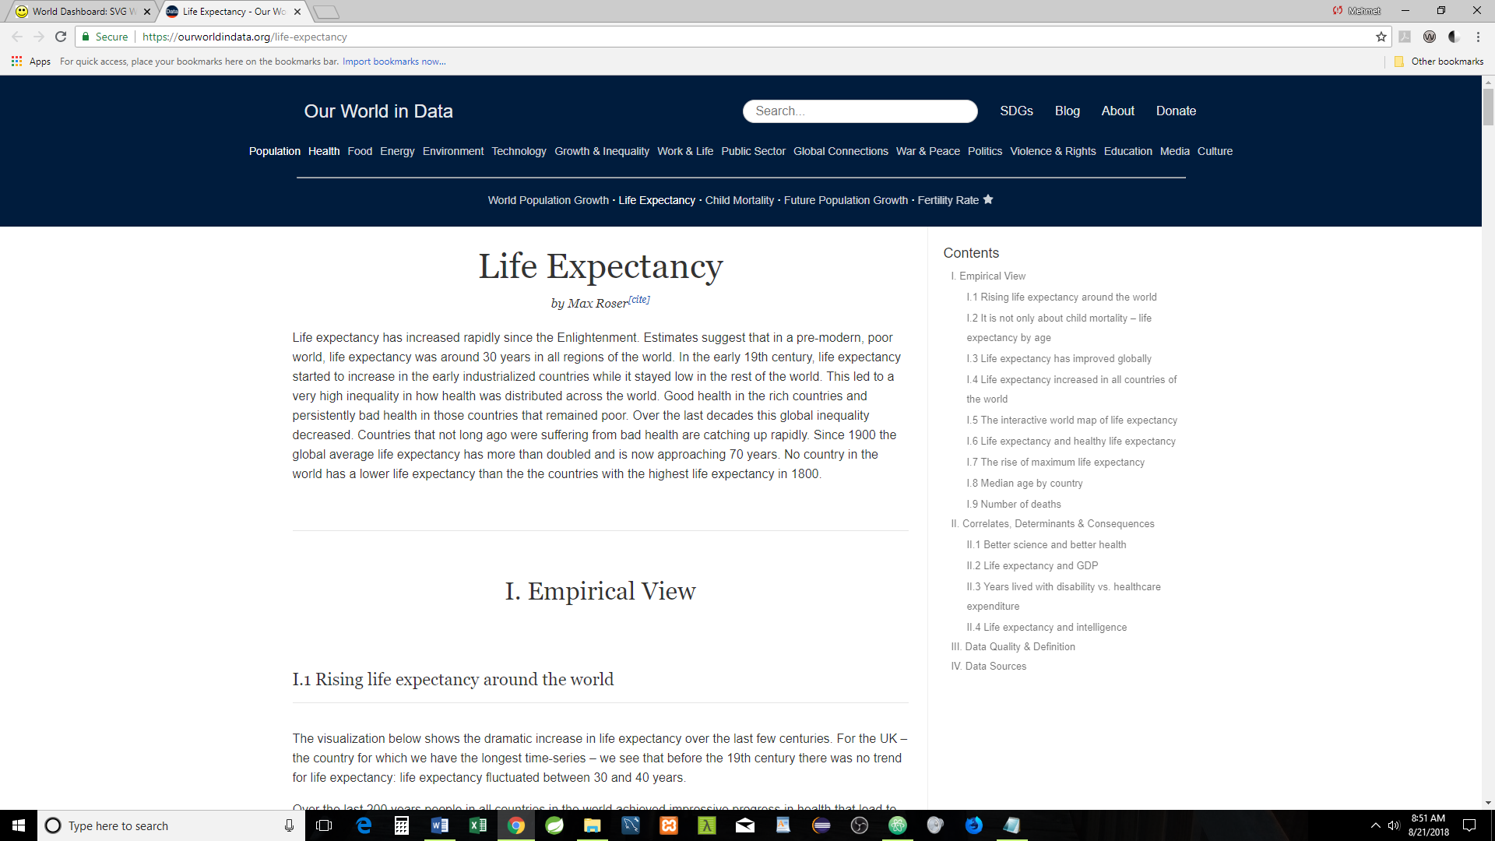

Countries with the Country Codes

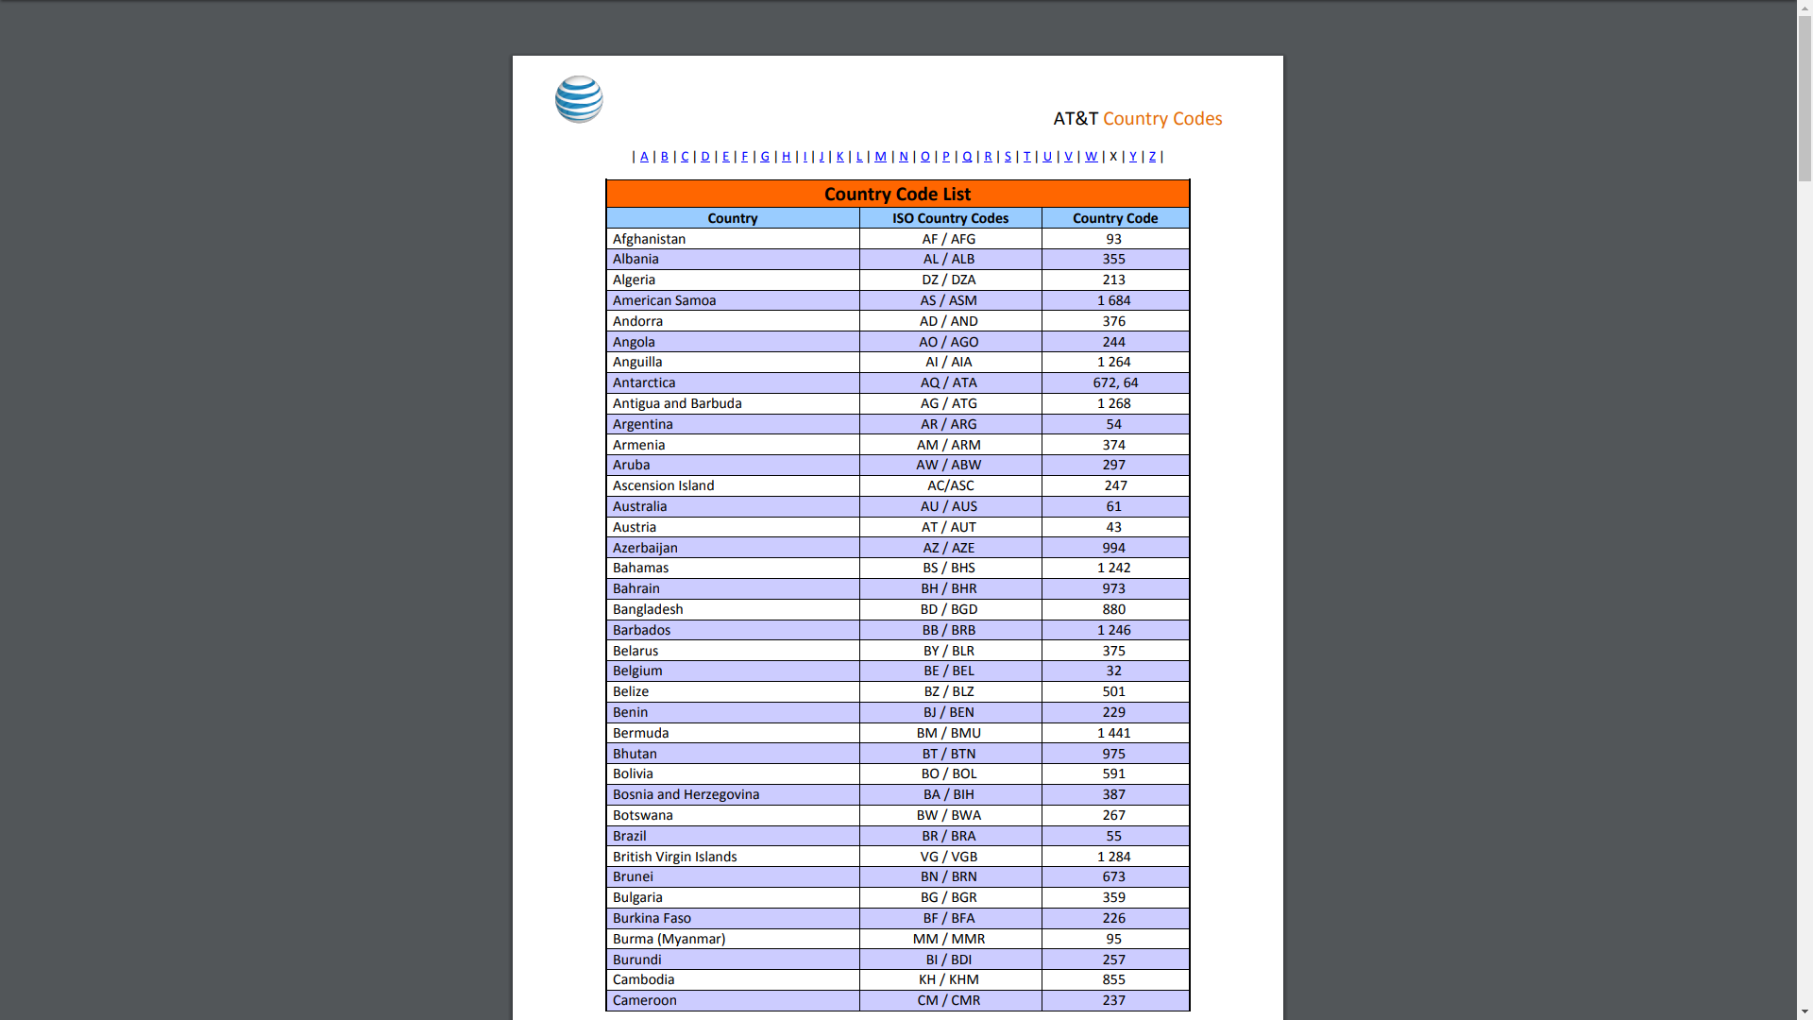

World Traffic Directions

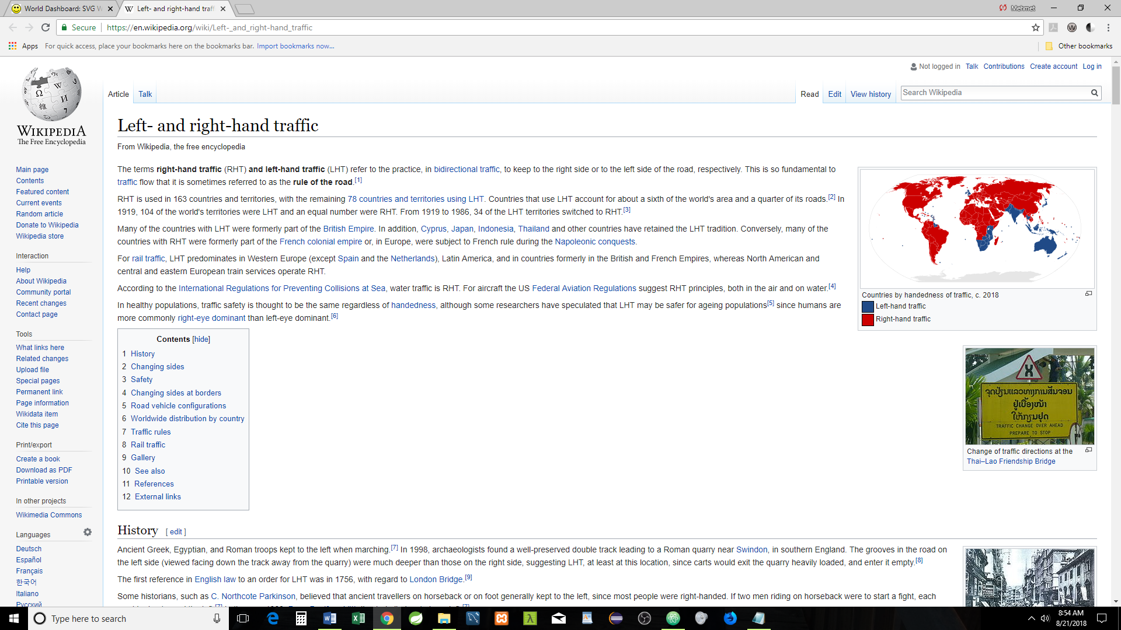

HDI: Human Development Index

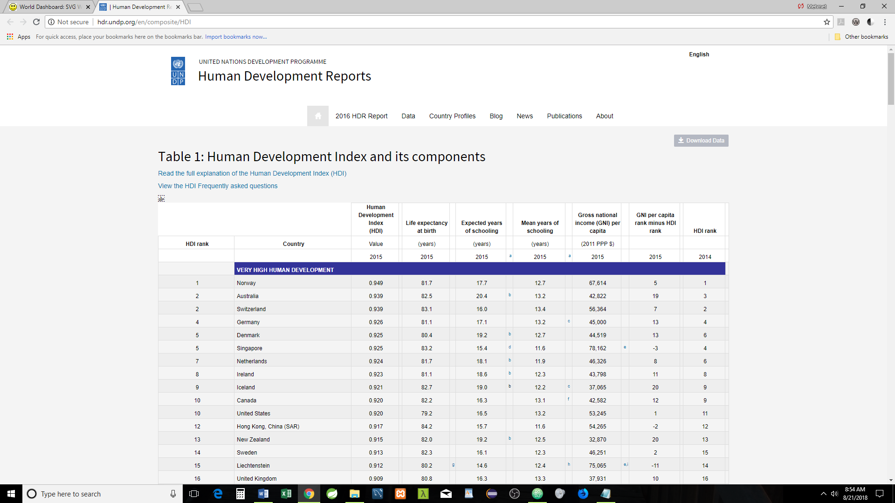

World Sex Ratio

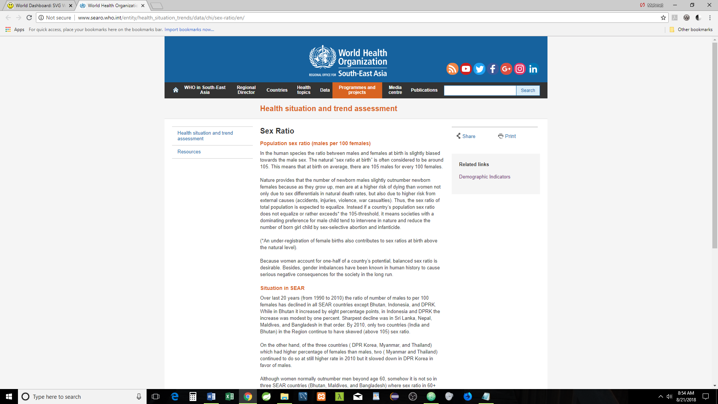

Distribution of Family Income – GINI Index

